Mission impossible

Project - math game 2023

**Documentation**

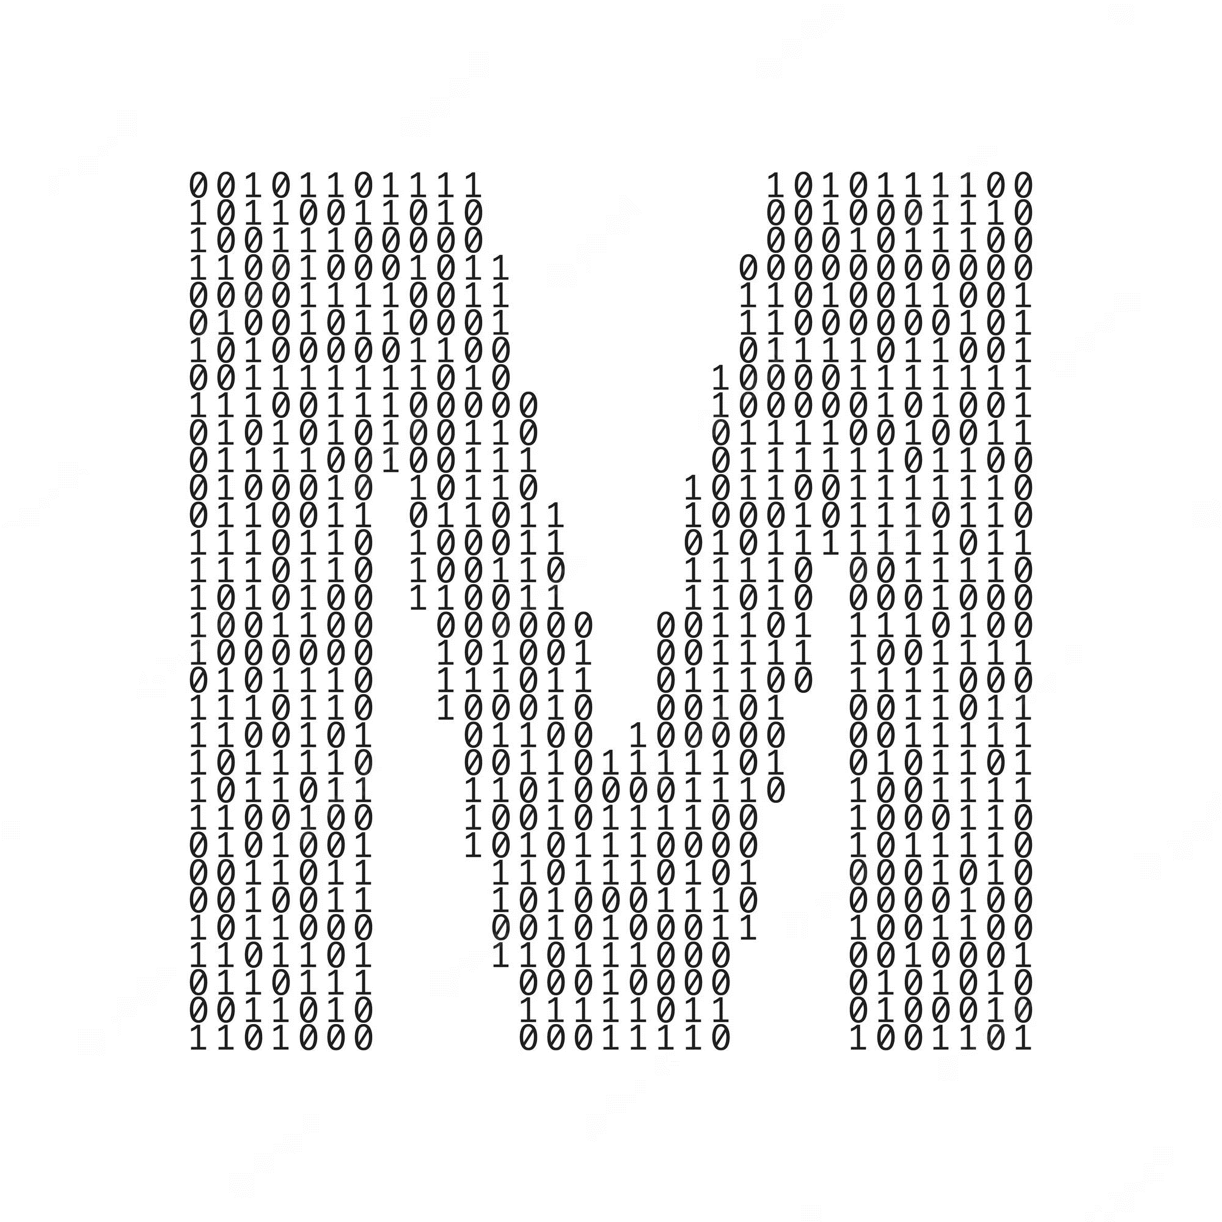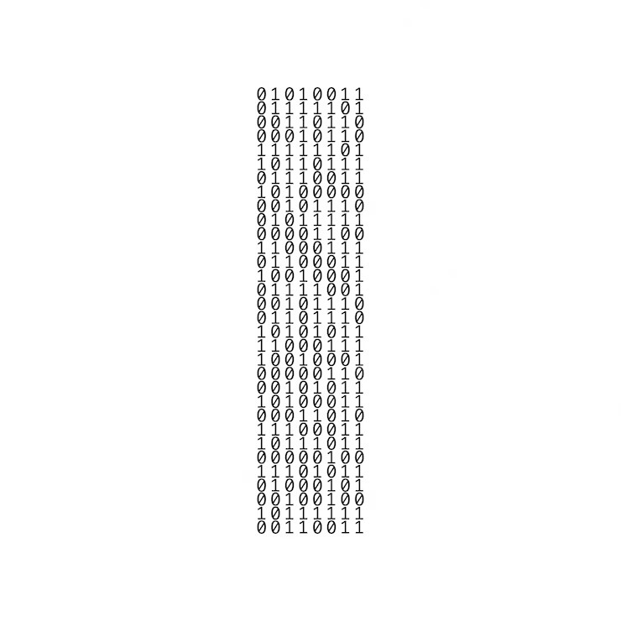

btd  
Binary to decimal

**Table of Contents**

Team 3

Was it difficult? 3

What did we use? 4

Resume 4

Idea 5

Game model 5



# Team

* + Kristina Zheleva (Scrum trainer)
* [KMZheleva21@codingburgas.bg](mailto:KMZheleva21@codingburgas.bg)
  + Lazar Apostolov (Frontend developer)
* [LPApostolov21@codingburgas.bg](mailto:LPApostolov21@codingburgas.bg)
  + Svetoslav Zhelev (Backend developer)
* [SNZhelev21@codingburgas.bg](mailto:SNZhelev21@codingburgas.bg)
  + Dimitar Georgiev (QA)
* [DKGeorgiev21@codingburgas.bg](mailto:DKGeorgiev21@codingburgas.bg)

# Was it difficult?

|  |
| --- |
| Difficulties: |
| 1/10 – not difficult \ 10/10 – very difficult |



|  |  |
| --- | --- |
| Communication | 2/10 |
| Code | 4/10 |
| Teamwork | 5/10 |
| Role distribution | 1/10 |

# What did we use?

1. Teams
2. Discord
3. C++
4. Visual studio
5. Word
6. Power point

# Resume

Hello! We are Mission Impossible and we would like to tell you a little bit about our game. The game is called “Binary to Decimal” and it's mainly about solving math equations. The catch is - all the numbers are written in their binary forms. We expect the player to decipher and solve them, earn a letter after a correctly solved one, and in the end they have to write the word they got.If they write the word correctly, they win the game. Good luck!!!

# Idea

The idea of the game is to help other students understand more about decimals and binary operation and how to transform a binary number to a decimal one and around. They will learn how to think faster and what's more, they will improve their mathematical knowledge.

# Game model